**Danube Delta Maps Intelectual Output no.2  
Colegiul National Ion Neculce and URBAN2020 Association  
  
Danube Delta over 30 years**

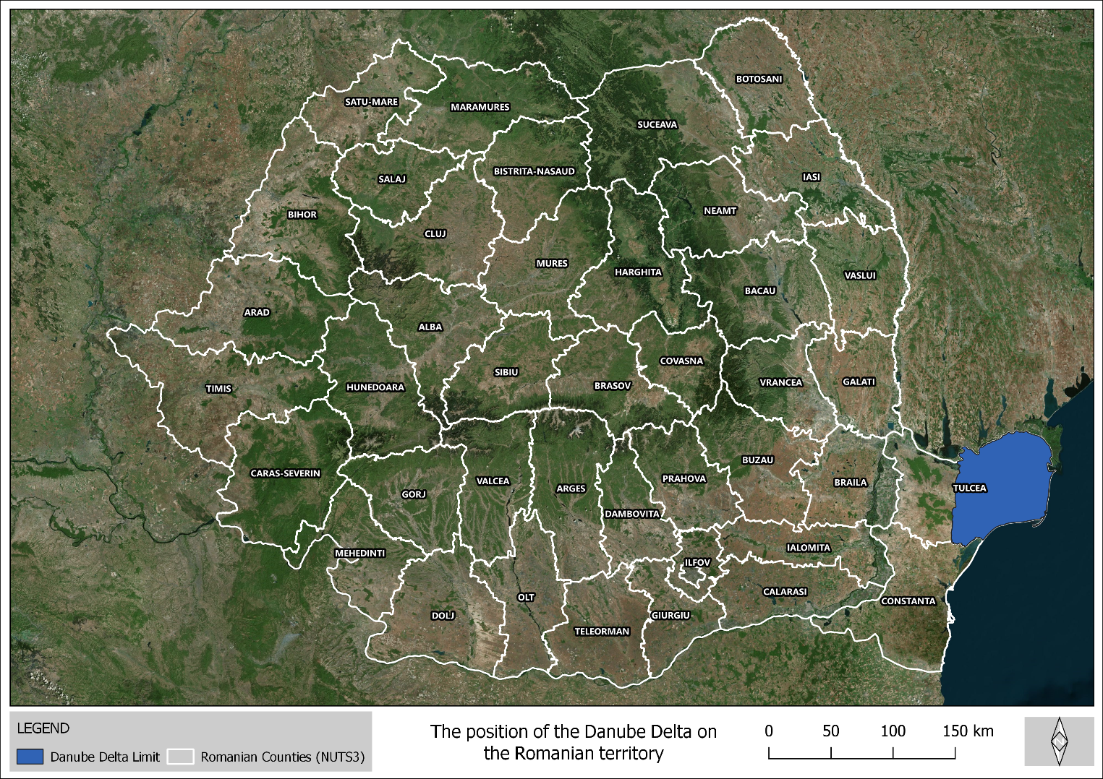

**Map no. 1. Danube Delta position in the national territory**

The first map made by the students was the location of the Danube Delta in the national territory. The location map is important because depending on the geographical position in a smaller or larger territory, in this case in the national territory of Romania, certain conclusions can be drawn regarding accessibility, economic opportunities (tourism) but some differences can also be distinguished. climate issues.

It is observed that the Danube Delta is located in Tulcea County (NUTS3) and the town of Sulina on the Danube branch of the same name is the easternmost point in Romania. As a conclusion, the winds in the area are stronger, coming from the east from the Black Sea while the precipitations are lower than in the rest of the country (in Romania the precipitations decrease from west to east).

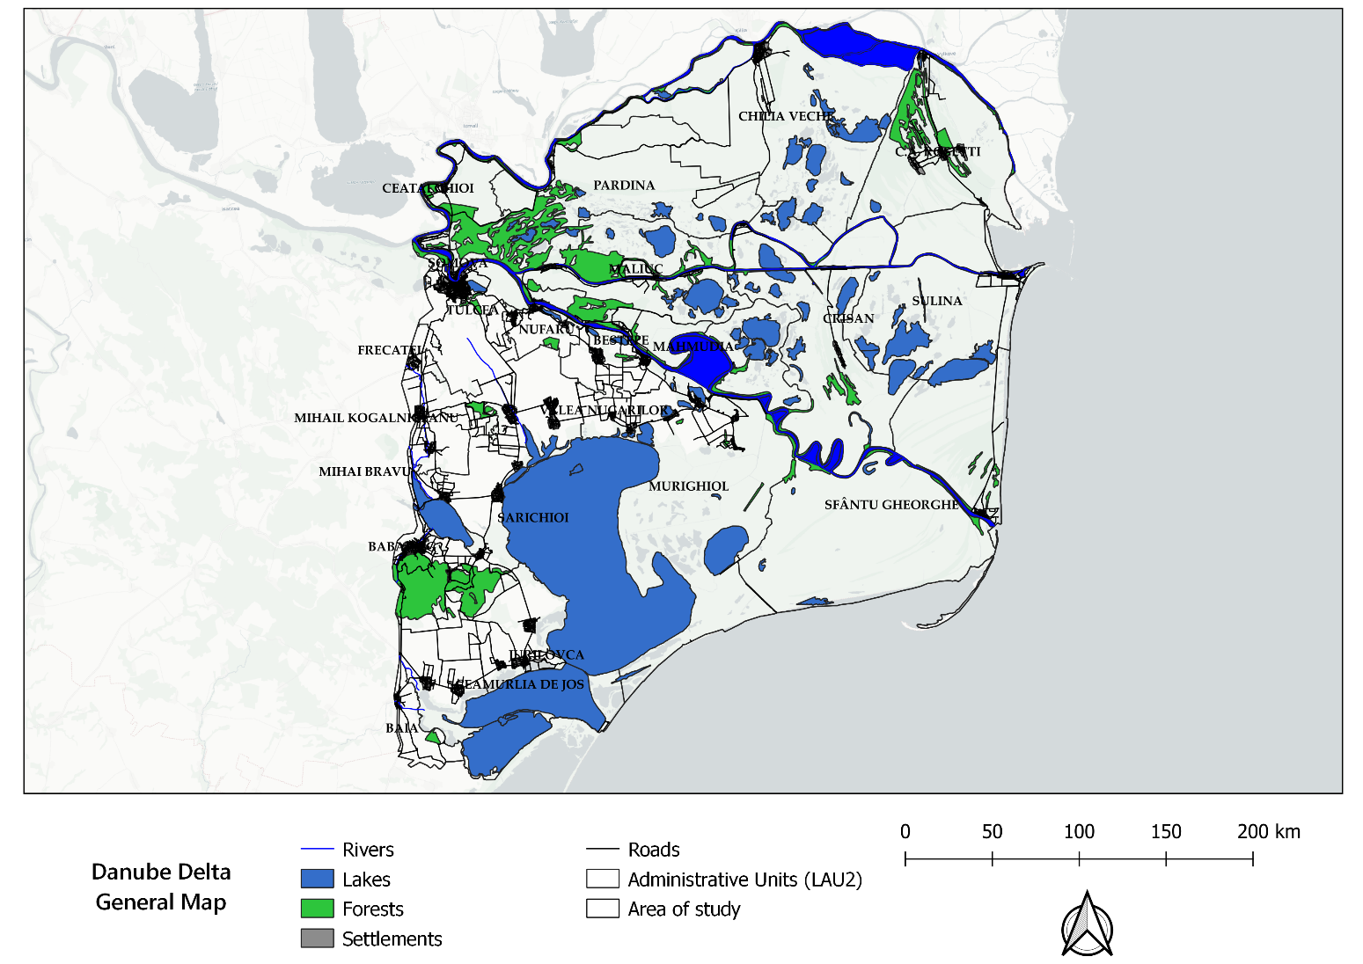

**Map 2. General map of the Danube Delta**

The general map is a graphic representation of the area which, as its name suggests, has some natural characteristics of the area, both anthropogenic and natural. Among them are the transport network, the settlements, the hydrographic network, the vegetation areas (forests), the administrative division and toponymy elements such as the names of the localities.

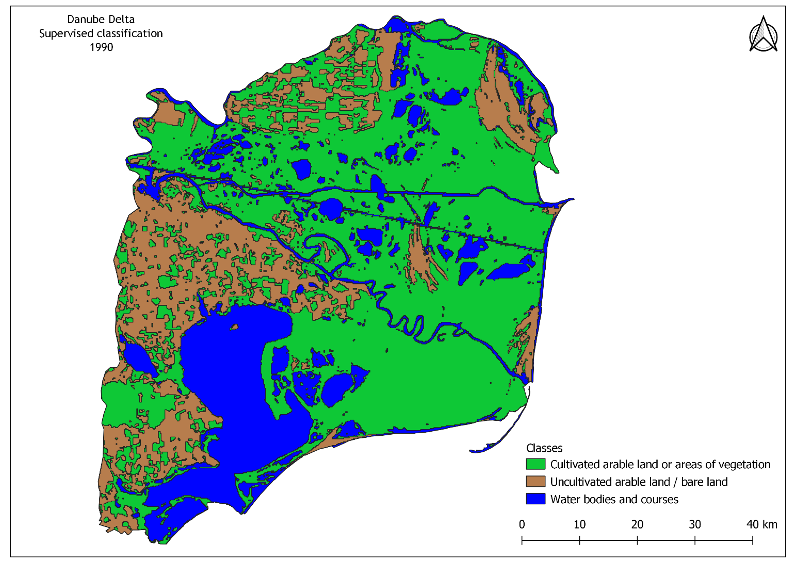**Map 3. Supervised classification of the Danube Delta for the year 1990**

Supervised classification is a process of dividing the utility of the land by analyzing and geoprocessing false color satellite images. For this purpose, 3 classes have been delimited. Areas covered by water, and arable areas (cultivated or uncultivated) at the time of making the image. This 1990 landmark was chosen for comparative purposes.

Thus, the green or vegetation-covered areas, the areas with bare soil but also the water bodies are noticeable.

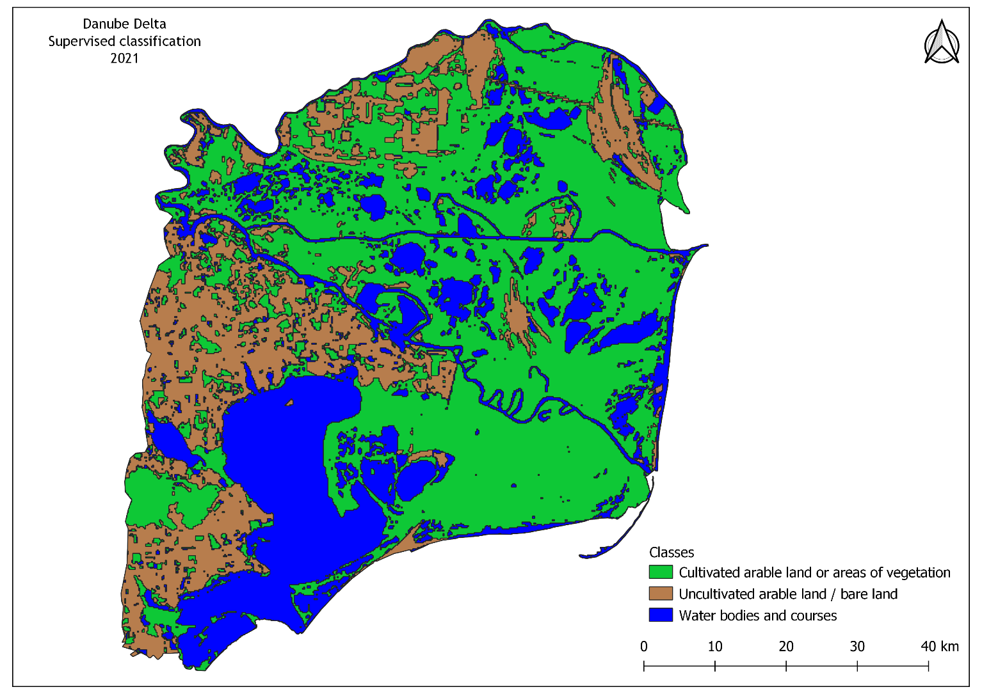

**Map 4. Supervised classification of the Danube Delta for the year 2021**

The supervised classification for 2021 was made following the same methodology, the same number of classes, the image was passed through the same spectral filter and more importantly the image is chosen from the same month of the year as in 1990.

Comparing the two images you can see the differences in size between surfaces in terms of the 3 classes. For example, the fact that water bodies have a larger surface area in 2021 than in 1990. This can be attributed to global warming, regularizations started during the communist period but also natural erosion processes made by water during the 30's. for years.

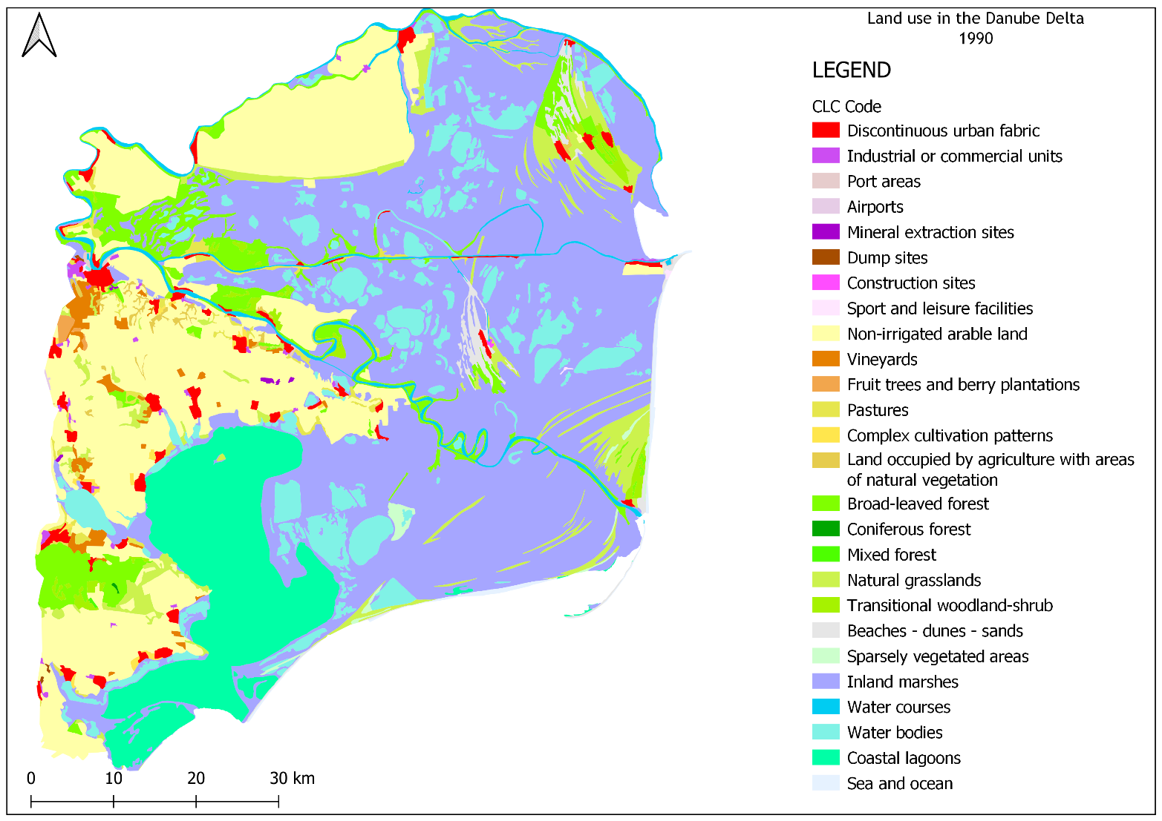

**Map 5. Land use - Corine Land Cover 1990**

Corine Land Cover is a set of land use data belonging to the European Copernicus Monitoring Service.

These data sets contain several classes and uses, from natural areas to anthropogenic areas. As well as the supervised classification map, these train usage analyzes based on the Corine Land Cover data sets were made for comparative purposes to distinguish differences that occurred over the years.

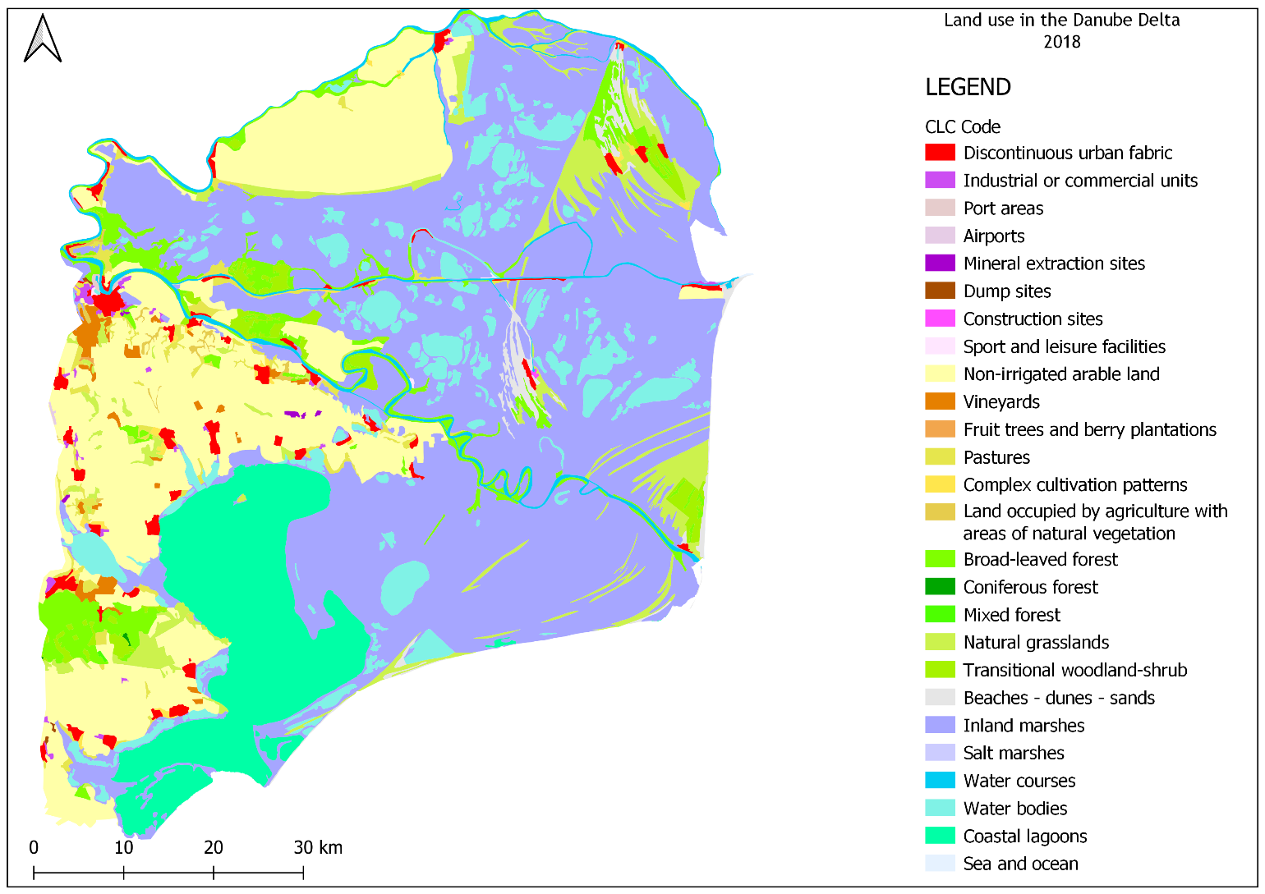

**Map 6. Land use - Corine Land Cover 2018**

Unlike the supervised classification, the Corine Land Cover datasets are made for fixed years, 1990, 2000, 2012 and 2018. Therefore, the datasets for the years 1990 and 2018 (the most recent databases) were chosen. Together with the students, differences and similarities were identified between the land uses that occurred between the two moments in time.

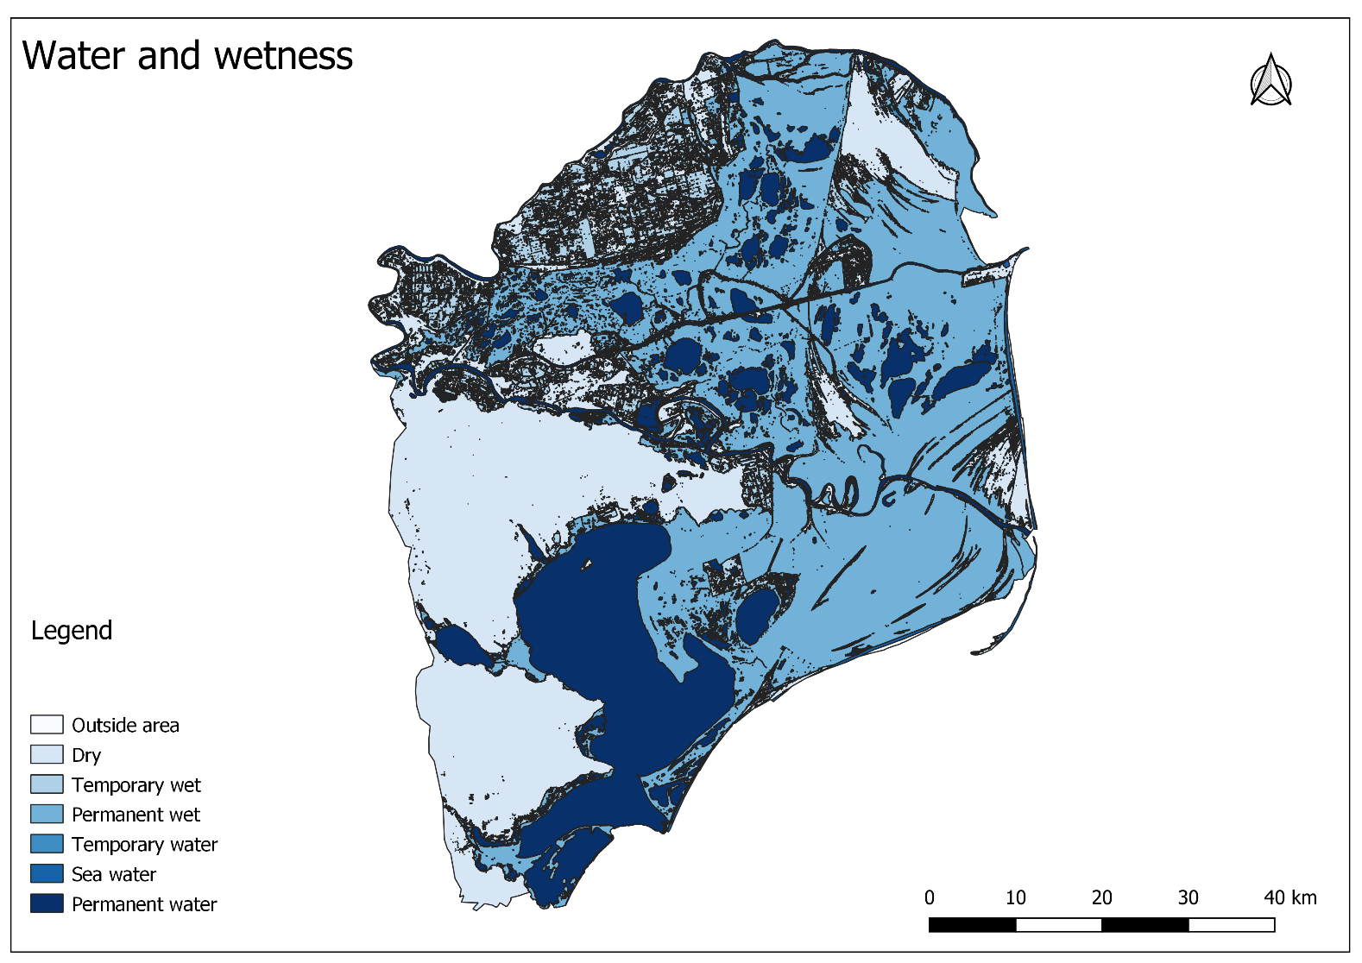**Map 7. Water and Wetness**

The combined Water and Wetness product is a thematic product showing the occurrence of water and wet surfaces over the period from 2009 to 2018. The products show the occurrence of water and indicate the degree of wetness in a physical sense, assessed independently of the actual vegetation cover and are thus not limited to a specific land cover class and their relative frequencies.

Thus one can distinguish the areas that are always covered by water or those that are covered by water only temporarily as well as the areas that are wet, swampy, etc.

This type of map is very useful for certain soil analyzes and agricultural analyzes for various agricultural developments but not only.